FOR IMMEDIATE RELEASE

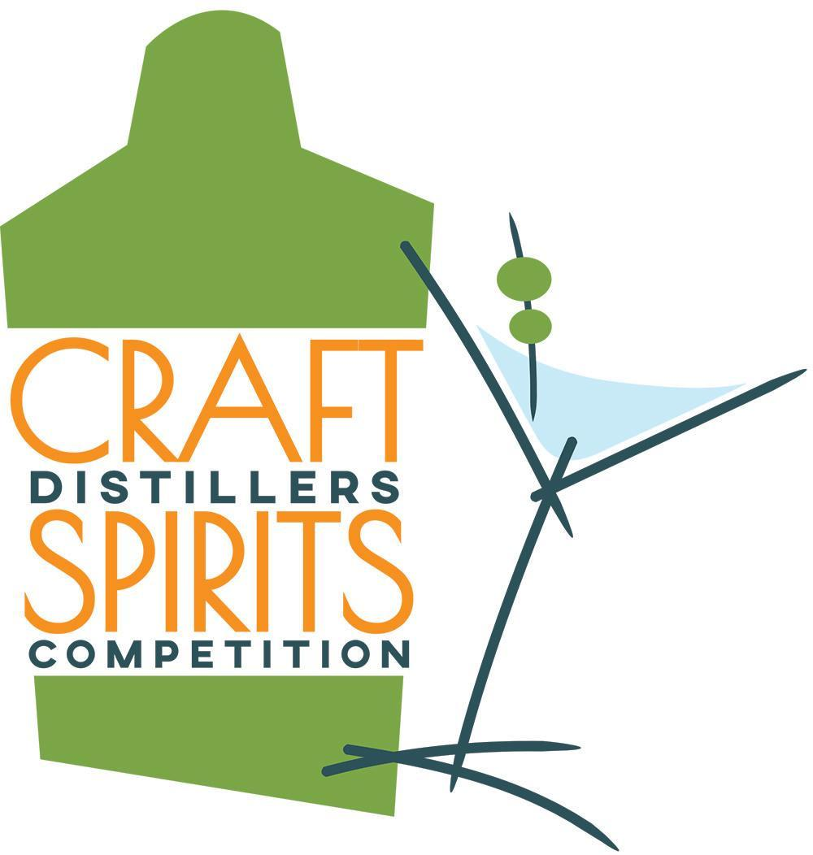

2023 Craft Distillers Spirits Competition Winners Announced
Best of the Best Awarded to Garrison Brothers Distillery’s Guadalupe Whiskey

December 18, 2023 (Santa Rosa, Calif.) — Winners have been announced for the 2023 Craft Distillers Spirits Competition, which took place in Santa Rosa, Calif., earlier this month. Taking the top spot this year is Guadalupe, a Texas straight bourbon whiskey finished in a port cask from Garrison Brothers Distilling in Hye, Texas. Judges described Guadalupe as “Very elegant”; “Warm finish”; “Delicious.”
Garrison Brothers Master Distiller Donnis Todd says, “What sets Guadalupe apart is the unique Texas climate, with its dramatic temperature fluctuations, and our careful selection of the right wet port barrels. This combination is key to Guadalupe's distinctiveness. Our goal was to capture and highlight the port notes, offering bourbon enthusiasts the same thrilling experience I get when discovering these exceptional barrels in our barns.
“The viscosity and sweetness [of Guadalupe] works perfectly with its 107-proof intensity to create the perfect mouthfeel — layers of pleasant bourbon and port flavors.”
Debra Del Fiorentino, who owns, manages and produces professional competitions in the wine, cider and spirits categories, established the Craft Distillers Spirits Competition in 2017 to give smaller producers a place to stand out. Any distiller that is bonded and sells its spirits publicly can enter, no matter where in the world it’s headquartered. The 2023 competition saw a record number of entries for this young competition, continuing the expansion experienced each year since its founding.
“As a fairly young competition, we’re still experiencing growth in our entry pool as word gets out,” says Del Fiorentino. “It’s absolutely the right time to spotlight small producers, many of which are struggling for survival right now. Any support we can offer to keep these amazing craft distilleries in business is definitely worth our efforts.”
Rob Cordes, marketing director for Garrison Brothers Distillery, weighs in: “As a small craft distillery, it's crucial for us to understand how our bourbon resonates with expert judges and to track our progress over the years. [Donnis] is committed to continual improvement, striving to craft a better bourbon today than we did yesterday. Awards from competitions are a valuable gauge for us, helping to see if others share our appreciation for the quality we're achieving.”
The Craft Distillers Spirits Competition is judged by fellow distillers, qualified members of the media, spirits and distilling educators and researchers, and retail buyers. This mix of experts gives the results professional weight and increases marketing opportunities for medal winners. A list of Best of Class winners follows this announcement.
The next Craft Distillers Spirits Competition will take place December 11-12, 2024; deadline for entry is December 6, 2024.
For more information, visit Wine and Spirit Competitions Management and Production at https://www.winecompetitions.com

—END—

2023 Craft Distillers Spirits Competition Best of Class Winners

Best of the Best, Best Whiskey, Best Special Barrel Finish Bourbon
Garrison Brothers Guadalupe (GG*, 98 pts.)
Best American Craft Whiskey
Weldon Mills Distillery Rockfish Whiskey (BOC, G, 92)
Best Straight Bourbon
Redwall Distillery Sedona Bourbon Whiskey (BOC, G, 92)
Best Other Bourbon
Garrison Brothers Distillery Balmorhea (BOC, G, 91)
Best Small Batch Bourbon (10 Years or Younger)
Uncle Nearest 1884 Small Batch Whiskey (BOC, GG, 95)
Best Single Barrel American Whiskey
Crater Lake Spirits Black Butte Whiskey Cask Strength (BOC, GG, 98)
Best Straight Rye Whiskey
Uncle Nearest Uncut and Unfiltered Straight Rye Whiskey (BOC, GG, 97)
Best Small Batch American Aged Rye Whiskey
Crater Lake Spirits Estate Rye Whiskey Cask Strength (BOC, G, 93)
Best Whiskey (Tennessee)
Uncle Nearest Master Blend Edition Batch 032 (BOC, G, 91)
Best Vodka
Weldon Mills Distillery Dray 25 Vodka (BOC, G, 93)
Best Tequila & Best Reposado
Rey Coyote Reposado (BOC, GG, 97)
Best Tequila (Extra- Añejo)
Cierto Tequila Private Collection, Extra Añejo (BOC, GG, 97)
Best Tequila (Blanco)
Familia Camarena Tequila Silver/Plato (GG, 95)
Best Tequila (Añejo)
Cierto Tequila Reserve Collection, Añejo (BOC, G, 92)
Best Mezcal
Catedral De Mi Padre Mezcal Espadin (BOC, G, 92)
Best Brandy
Napa Valley Brandy Co. Solera Gold (BOC, GG, 97)
Best Gin
Botanery Barn Distilling Revivalist Garden Gin (BOC, GG, 97)
Best Gin (Flavored/Infused)
Weldon Mills Distillery 3 Hamlets Lavender Lime Gin (BOC, G, 92)
Best Liqueur
Jack From Brooklyn Sorel Liqueur (BOC, GG, 98)
Best Ready to Drink (RTD)
High Noon Hard Seltzer Watermelon (BOC, G, 92)

For a full list of medal winners, go to https://www.winecompetitions.com/2023-craft-distillers-results

—END—

