FOR IMMEDIATE RELEASE

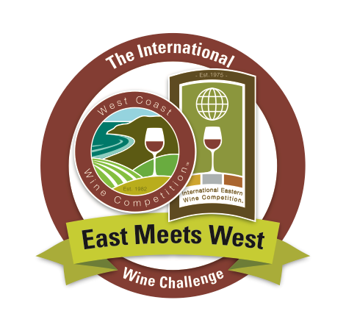

**2024 East vs. West International Wine Competition Announces Winners   
Bluestone Vineyards’ Pinot Meunier Takes Top Honors**

September 23, 2024 — The 2024 International Eastern Wine Competition and West Coast Wine Competition match-up has announced Bluestone Vineyard’s 2023 Pinot Meunier as the Best of the Best for the final EAST MEETS WEST COMPETITION.

Scoring an impressive 99 points, the wine wowed judges, who described it as “Seductive,” with “Rich, lush, wild cherry,” and added “Impeccable winemaking.” Located in Virginia’s Shenandoah Valley AVA, Bluestone ([www.bluestonevineyard.com/](https://www.bluestonevineyard.com/)) takes its name from the "bluestone" (a type of limestone) that is a main component within the local soil. Bluestone Vineyard is committed to crafting small-batch wines from locally sourced and estate-grown fruit that showcase the very best in each variety and each vintage. The result is a wine selection that constantly evolves to reflect the passion of the winemaker, the year, the weather and the fruit. In addition to this year’s top winner, five other Bluestone entries earned gold awards or better.

This two-pronged East vs. West contest first chooses winners in the separate International Eastern Wine Competition and West Coast Wine Competition (see parameters below) before the top wines from each are pitted against each other in an East Meets West Taste Off.

Founded in 1975, the International Eastern Wine Competition is the oldest competition still in existence. Eligible wines can come from Central and South America, Europe, Africa, Mexico (mainland), Canada (except British Columbia), and all U.S. states not listed below.

The West Coast Wine Competition was established in 1982 and is open to wines from Australia, China, India, Japan, Middle East, New Zealand, Pacific Rim nations, Russia, Tasmania, British Columbia (Canada), Baja Mexico, and the U.S. states of Alaska, Arizona, California, Hawaii, Idaho, Nevada, Oregon, Utah, and Washington.

Each competition is judged independently by experts familiar with the styles and varieties specific to each geographic region. Ten years ago, the final judging round was added.

A third competitive element, focused specifically on Riesling wines, gives the competition even more layers of intrigue. This year, Navarro Vineyards’ Anderson Valley Riesling won this category, as well as a Best of Class Award in the West Coast Wine Competition.

Below is a list of Best of Show winners awarded at this year’s competition.

Visit <https://www.winecompetitions.com/2024-east-meets-west-results> for more information.

— END —

**2023 International East Meets West Wine Competition Winners   
—East Coast Wine Competition Winners—**

**Best of the Best  
Best of the East Red Wine**Bluestone Vineyards 2023 Pinot Meunier (BOC, GG, 99 pts)  
Judges: “Seductive”; “Rich, lush, wild cherry”; “Impeccable winemaking.”

**Best White Wine**Bluestone Vineyard NV White Table Wine Beau (BOC, GG, 97)  
Judges: “Pineapple, kiwi”; “white flowers, apricot.”

**Best Rosé Wine**Links Bridge Vineyards 2023 Rose of Barbera (BOC, GG, 98)  
Judges: “Bright, fresh”; “Juicy”; “Brambly.”

**Best Sparkling Wine**Black Star Farms NV Blanc de Blanc (BOC, GG, 97)  
Judges: “Floral”; “authentic”; “crisp apple”; “Balanced linen.”

**Best Late Harvest/Dessert Wine**Bluestone Vineyard 2022 Moscato (BOC, GG, 96)  
Judges: “Wildly expressive”; “Pear”; “Balanced with spice”; “Light.”

**Best Fruit Wine**Holy-Field Vineyard & Winery NV Over the Rainbow Raspberry (BOC, GG, 95)  
Judges: “Refreshing, bright.”

**Best Port**JOLO Vineyards NV Muddy Paws (BOC, G, 92)  
Judges: “Cordial cherries with a honey and walnut liqueur finish.”

**—West Coast Wine Competition Winners—**

**Best of the Best  
Best of the West Red Wine**Carol Shelton Wines 2022 Coquille Rouge (BOC, GG, 96)  
Judges: “Good structure”; “nice middle finish with multiple layers.”

**Best White Wine**Navarro Vineyards 2023 Mendocino Chardonnay (BOC, GG, 97)  
Judges: “Citrus, green apple”; “Long crisp finish”; “lively acidity throughout.”

**Best Rosé Wine**Arrington Vineyards 2023 Firefly Rosé (BOC, GG, 96)  
Judges: “Strawberry”; “good color, good body”; “Balanced fruit.”

**Best Sparkling Wine**Pennyroyal Farm 2016 Almittey Brut (BOC, GG, 98)  
Judges: “Honey almond”; “Big mousse”; “nice toast”; “Weight good on the palate.”

**Riesling Challenge Winner (BOC, GG, 97)**Navarro Vineyards 2023 Anderson Valley Riesling  
Judges: “Rich, bright”; “beautiful, classic, balanced.”

**—END—**