FOR IMMEDIATE RELEASE

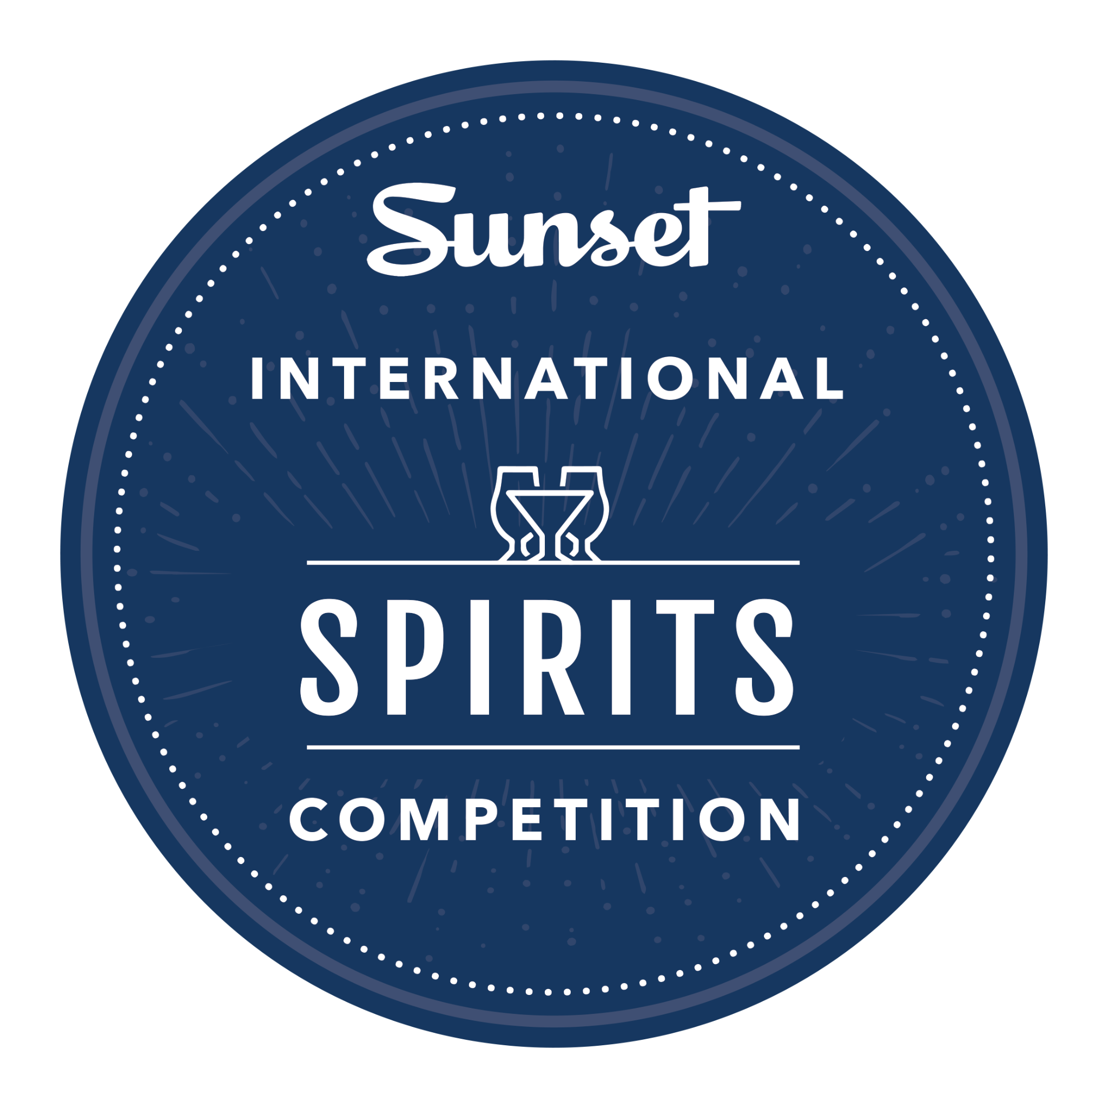

SANTA ROSA, CALIF. – Winners have been announced in the 2023 Sunset International Spirits Competition. This year, for the first time, a brandy has taken top honors. After a full day of tasting and discussion, Pendray’s Distillery in Paso Robles, Calif., wowed judges with its XO Brandy, which they described as “caramel and cardamom”; “balanced”; with a “simple finish.”

A sister to PerCaso Winery and PasoPort Wine Company, Pendray’s has been distilling since 2013. Its XO Brandy is inspired by the illustrious brandies of Cognac, carefully aged and blended from select brandy stocks that had been aged 7 to ten years in French oak barrels. The delectable libation was named Best of the Best, Best of Class and Best Brandy, and awarded 98 points.

Other medal winners included products from across the globe, including England, the Channel Islands (between England and France), Mexico, Denmark, and several U.S. states. “I continue to be impressed by the wide breadth of competitors, year after year,” says Debra Del Fiorentino, owner of Wine Competitions Management and Production, which oversees the Sunset International Spirits Competition. “As word gets out about this prestigious event, we have more interest — and entries — from around the world. It’s a testament to the reputation Sunset has established as a style leader and lifestyle brand.”

Now in its fifth year, the Sunset International Spirits Competition is open to commercial distillers of all sizes, with judging categories based on spirit type and production techniques. Winning producers will be featured in a Spring release of a Spirits Special non-print, digital edition with supporting microsite. Promotions for Spirits Award Special Issue will be placed in sunset.com, Sunset eNewsletters and Sunset social sites. The edition will be promoted and available for 12 months or until the 2024 Spirit Awards winners are announced.

2023 Sunset International Spirits Competition
Best of Class Awards

Best of the Best, Best of Class, Best Brandy
Pendray’s Distillery XO Brandy (GG, 98 pts.)
Judges: “caramel and cardamom”; “balanced”; “simple finish”

Best Liqueur
Brucato Amaro Chaparral (GG, 98 pts.)
Judges: “big, powerful”; “freshly ground peppercorns”; “coriander”

Best Vodka Flavored/Infused
Jewell Distillery Citron Vodka (GG, 97 pts.)
Judges: “lime peel”; “lemongrass, natural flavors”; “enticing”

Best Vodka
Royal Mash Vintage 2020 (GG, 98 pts.)
Judges: “iconic potato vodka”; “James Bond”

Best Other Agave Spirits
Venus Spirits El Ladrón Yolo - CA Roasted Agave (GG, 97 pts.)
Judges: “great flavor, solid aroma”; “cinnamon, floral nose”; “creamy”

Best Tequila
Cierto Tequila Private Collection, Extra Añejo (GG, 97 pts.)
Judges: “warm, autumnal, beautifully aged”; “nice notes of baking spices, caramel, white peppers, dried papaya and pineapple acidity”

Best Whiskey
Savage & Cooke Straight Bourbon, Ultra Premium (GG, 98 pts.)
Judges: “a little spicy”; “earthy, very complex”; “elegant finish”

Best Gin
Hinterhaus Distilling South Grove Gin (GG, 95 pts.)
Judges: “nice floral on palate”; “lovely, complete”

Best Mezcal
Cutwater Spirits Mezcal Reposado (GG, 95 pts.)
Judges: “spice on nose”; “jalapeño, tabasco, citrus”

Best Hard Seltzer
E&J Gallo High Noon Grapefruit (GG, 96 pts)
Judges: “nose of grapefruit pith and ripe grapefruit”; “nice, pleasing and refreshing”

Best Ready to Drink (RTD)
Cutwater Spirits Spicy Bloody Mary (G, 98 pts.)
Judges: “well balanced, fresh”; “clean and spicy”

For a full list of medal winners, go to Results Sunset Spirits Competitions 2023

